**Aug. 17, 1948. A. K. BREWER ET AL 2,446,997**

MOLECULAR DISTILLATION PROCESS AND APPARATUS FOR THE SEPARATION OF ISOTOPES, ETC.

Filed March 11, 1943 2 Sheets-Sheet 1

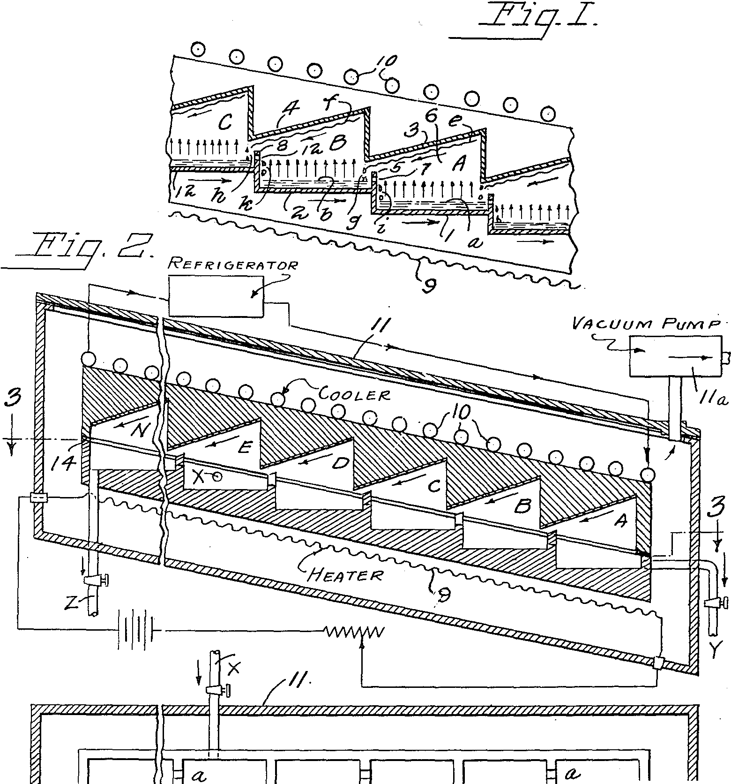

*a,*

*N*

z

£

*D*

C

8

*A*

t-

*a.*

*a,*

*h,*

-

·t

*y*

INVENTORS

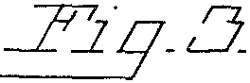*AUBREY KEtTH BREWE=-R* ,?

*.5AMUEL... L. MADOR5K,* "

*c:::7' v.,--:z-.* -- ,,L...

ATTORNEY

**Aug.** 17, **1948. A. K. BREWER ET AL 2,446,997**

MOLECULAR DISTILLATION PROCESS AND APPARATUS FOR THE SEPARATION OF ISOTOPES, ETC.

Filed March 11, 1943 2 Sheets-Sheet 2

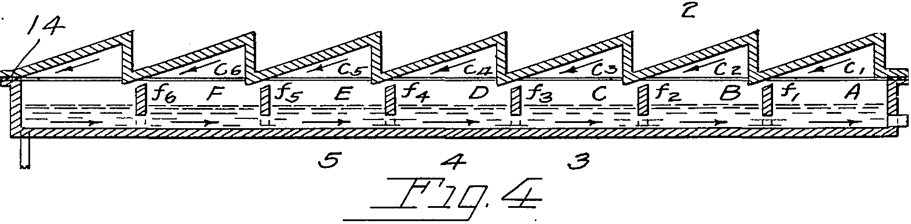

6

*5*

*4-*

*3*

*I*

*6*

2

*I*

*To VAcuuM PuMP*

/;/ */4*

*I <--Y'*

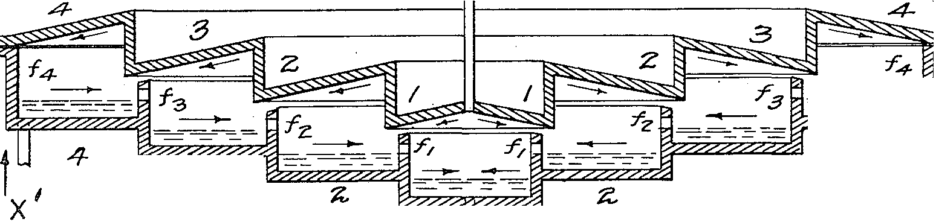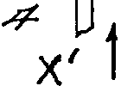

- ---

---

*3*

*:3*

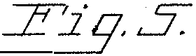

*AuBR£Y KEITH f5REYYER* '9'-1,-:

*<)*

*0,4/YJUEL L. Ml'WOR5KY*

INVENTOR5

BY £..-.-<.

ATTORNEY

# Patented Aug. 17, 1948

UNITED **STATES**

**2,446,997**

**PATENT OFFICE**

Z,448,99Y)

MOLECULAR DISTILLATION PROCESS AND

**APPARATUS FOR** THE **SEPARATION** OF

, ISOTOPES,ETC. .

Aubrey Keith Brewer, Richland Center, Wis., and Samuel Leo Madorsky, Chicago, assignors, by mesne assignments, to the United States of America as. represented by the United States Atomic Energy Commission

m.,

Application March 11, 1943, Serial No. 4'78,844

13 Claims. (CL 202-52)

(Granted under the act of March 3, 1883, as

**amended April 30, 1928; 3'70 O. G. '757)**

1 **2**

The invention herein described may be made and used by or for the Government of the United States without payment to either of us of any royalty therefor. ·

The present invention relates to the separation 1 of liquid mixtures, especially liquids containing isotopes, by the method of free evaporation.

When a liquid containing isotopes, for example,

is enclosed in a chamber evacuated to a very low

asisnearly the case, since they have nearly iden­ tical boiling Points, kinetic theory requires that the abundance ratio of light to heavy mOlecules in the vapor leaving the liquid shall be

times the abundance ratio in the liquid,

Thus we see that in the vaPor and, consequent-

pressure, of the order of a millimeter of mercury, and the temperature of the liquid is so adjusted that the vapor pressure of this liquid is of the order of a millimeter or less of mercury, the in­ dividual atoms or molecules leaving the liquid will

**10** ly, in the condensate, the ratio of the heavy to the light isotope is smaller than in the liquid phase being evaporated. A partial separation of the two isotopes is thus effected; the condensate will contain a larger proportion of the light isotope

travel appreciable distances before returning to 15 and the residue, i. e., the evaPorating liquid, a

the liquid surface. If a condensing surface· is placed at a distance from the evaPorating sur­ face less than or equal to only a few times the mean free path of the atoms or molecules in the vapor and maintained at a lower temperature than the evaPorating surface, the relative abun­ dance of the isotopes in the condensate will be substantially the same as that in the vapor at the moment the vaPor leaves the liquid surface. This is due to the fact that the individual par­ ticles of the vapor, in traveling the short dis­ tance between the evaporating and condensing surfaces are not deviated much from their path by collisions with each other, the movement of the vapor being substantially unidirectional. If the system is kept evacuated to a point where the non.,.condensable particles, such, for example, as air molecule, are at a pressure of about 10-s or 10- 6 of a millimeter of mercury, the collisions of these particles, which are in a state of random motion, with the condensable particles of the vaPor will not be numerous enough to affect ap­ preciably the unidirectional motion of the con­ densable particle,s. As a result only a small num­ ber of the condensable particles leaving the liquid surface are returned to this liquid through col­ lisions in the vapor phase, and the composition of the vapor at the moment of condensation is substantially the same as at the moment of evap­ oration.

To illustrate the basic separating action, let us tak asimple case of a liquid containing two iso­ topes, the light and heavy molecules which carry them having masses m1 and m2. If the **vaPor**

larger proportion of the heavy isotope, than the original liquid. However, in most cases this sepa­ ration is very small and, in order to make a fur­ ther separation, the light and heavy fractions

20 have to be treated separately by a manifold repe­ tition of the same process, which in the past re­ quired the expenditure of a great deal of labor and material, ·

Separation of isotopes by free evaPoration has 25 been attempted previously in the case of mercury by Bronsted and Hevesy (Phil. Mag., 1922, 43, 3) who condensed the vapor in the form of a solid using a glass apparatus, by Mulliken and Harkins

<J. Am. Chem. Soc., 44, 37-65, 1922), who co'l-

30 densed the vapor as a liquid on a slanting roof, using also a glass apparatus, and by Harkins and

Madorsky <J. Am. Chem. Soc., 45, 591-601, 1923),

who employed substantially the method of Mulli­ ken and Harkins, but employed a large steel

35 apparatus.

In all these attempts the apparatus consisted of a single-operation cell, containing one evap­ orating and one condensing surface and involving a laborious process of collecting the fractions, re-

40 combining, and re-evaPorating them, before a perceptible separation of isotopes was accom­ plished.

The enormous amount of labor and material involved in the separation of isotopes by the use

45 of a single cell apparatus of the type employed l>Y Bronsted and Hevesy, Milliken and Harkins, and Harkins and Madorsky, may be appreciated by considering the simple case of a mixture of two isotopes of potassium, K39 and K41, The rela-

pressures of the separate isotopes are the sa e, 50 tive abundance of these isotopes is **94.6** percent

**2,446,997**

## 3 4

for the light and 5.4 percent for the heavy isotope respectively, so that in this case .the abundance **ratio** in the natural liquid is

5.4

94.6

Let us assume that we are going to increase R

**from** ·

5.4 50

**2** containing liquid *b* whose constituents are to be separated. The partition between trough **2 of** cell B and trough I of cell **A** is shown as wall Ii. This wall separates the liquid in the two cells and

5 is provided with an opening **l** to permit the liquid to overflow by gravity from cell trough **2** to trough I. ;

**A** condensing roof **4** is placed immediately above trough **2,** cell B, at such a slope that the

94.6 to 50

1. **e. from 5.4** percent to 50 percent of the heavy isotope KH in the mixture.

In this case the .separation factor S is equal to

IO condensed vapor will run down by gravity along its lower surface and will drop into cell C. Sim­ ilarly, the vapor risir.g from the liquid *a* in cell **A** condenses on roof **3** and the condensate flows by gravity into cell B. The condensing roofs must

50 5.4

50+ 94.6=

17·52

15 be made of such material that it is wetted by the condensate.

The number of separate beneficiating stages of evaporation, or "cuts" required to obtain a 50% concentration of K 41 is obtained from the equa­ tion

17.52=c.J::r

where m2 and m1 are equal to 41 and 39 respec­ tively, and X is the number of cuts. Solving this equation for X, we find X=115. One can readily see that the amount of work and material in­ volved in cutting the liquid potassium by a series of 115 separate beneficiating evaporations, would be staggering. This cannot be done without re­ combining the fractions, as for such purpose the amount of original material required to obtain, for example, 1 gram of a 50% heavy potassium

<assuming that in each cut one-half of the liquid potassium *1s* distilled off) would be:



which is equivalent to 4.2X1028 metric tons <cf. weight of the earth, 5.98 X1021 metric tons) . Hence, the fractions from each composition must be recombined again and again, and in the course **of** fractionation the amount of labor involved be­ comes enormous.

One object of the present invention is to avoid the enormous amount of labor and material in­ volved in effecting separations of this character. By the use of 115 cells in accordance with our invention the result described above can be ob­

Heating means for the liquid in the cells is pro­ vided, herein shown as electrical heating element **9** placed ·below .the cells and the temperature of

20 the evaporating liquid *a, b,* is adjusted to give the required speed of vaporization.

Cooling means for the condenser roofs is pro­ vided, herein shown as refrigerating element **ID** placed directly above roofs 3 and **4,** and the tem-

25 perature of the roofs is so adjusted that the vapor rising from liquid *a* and *b* will be condensed.

Means is also provided to minimize heat trans­ fer from the evaporating section to the condens­ ing section of the apparatus <by other than the

30 distilling liquid) herein shown as an insulating gap **14** <Figs. 2 to 5) which may be filled with a gasket, spacer, or wall, or glass, asbestos, or other good heat insulating material, if it is desired to support the condenser section on the evaporating

35 section, as shown in Figs. 2 through 5.

**Any** suitable arrangement may be employed to effect good heat transfer to the liquid in troughs I, **2** and from the condensate condensing on the condenser surfaces 3, **4.** Thus the coils may be

40 embedded in the elements to be heated and cooled, insulation may be used in the normal manner, and coils **ID** may be immersed in a liquid such as brine or mercury, confined, for example, in a tank having roofs **3, 4** as its bottom.

**45 Any** suita·ble means may also be employed to produce a very low pressure of residual gas in the cells, A, B, C; for example, the entire system may be enclosed In a. suitable casing (indicated

tained in one operation. The amount of original

diagrammatically at **11** in Figs. 2 and 3·)

50

which

material required to obtain one gram of 50:50 mixture of K 3 9 and K41 in accordance with our in­ vention Is equal to the ratio 50/50+5.4/94.6=17.5 grams, a number which is very small compared with the Impossible amount of 4.2 X 1034 grams.

Various modifications of our invention are shown schematically in Figs. 1, 2, 3, 4 and 5. Figure 1 shows an apparatus suitable for carry­ ing out the process of the invention wherein a series of cells are located slightly declined to the

can be evacuated, as by pump **11***a,* to reduce the non-condensable gas content of the cells to such extent as to provide molecular or unidirectional distillation conditions.

In operating this system as a molecular still 55 heat is applied through heating element 9 to cells I, **2** .. ,.• so that the vapor pressure of the con­ stituents of *a, b* . . . will reach some pressure, preferabl below 1 mm. of Hg. Assuming that

all the constituents of the liquid have identical

horizontal with the heating means positioned below the cells and cooling means above the condenser roofs; Figure 2 shows the arrangement of cells of Figure 1 inclosed in a suitable casing with cooling and heating means positioned within the casing; Figure 3 is a sectional view of the apparatus of Figure 2, taken on the line **3-3;** Figure 4 is a modified form of apparatus wherein all cells are located in one plane either horizontal or slightly inclined to the horizontal; Figure 5 is

60 vapor pressures, the rate of escape of the various

molecular species from the liquid surfaces of *a, b* • • . will be proportional to their relative molecular velocities. If *a, b* .•. contain molecules **of** masses m1 and m2 in concentrations n1 and n2,

65 the number of molecules escaping from the sur­ **face** can be shown by kinetic theory to have the ratio

*ni/.,/'in;*

#### n2/,/m,

another modified form of the apparatus wherein 70 the cells ar spaced concentrically. The method

of operation can be seen by referring to Fig. 1 in which cells **A** and B and part of cell C of a large system of cells are illustrated in detail.

Thus, when m1 is lighter than *m2* the vapor will contain an excess of the light constituent over that in the liquid by an amount equal to Vm2/ m1 Since substantially all non-condensable gases

**A** single cell B consists of an evaporating trough 75 have been removed from the system, the molecules

**2,448,997**

s

**6**

**escaping, for example, from b wlll move 1n a** procession across the gap or space 6 towards roof 4 without undergoing collisions with other molecules of random direction, and so without being deflected back toward *b,* so long as con­ ditions are maintained which avoid the presence of any undue number of molecules of random motion 1n this gap. The present arrangement facllitates the maintenance of such conditions in

which our invention has unique advantages, the invention may be employed advantageously in the separation of constituents of a liquid having dif­ ferent vapor pressures and operating on the prin-

5 ciple of high-vacuum equilibrium distillation. In this case the companent having the higher vapor pressure will be transparted in the direction **A to** B to C in Fig. 1, while the less volatile material will be transparted in the direction C to B to A.

several respects. Thus, for example, it facilitates 10 It is also possible for the system to combine the

**removal** of any freed occluded non-condensables; provides for maintaining the condensate on the· condensing roofs **3, 4** at such temperature that its vapar pressure is negligible compared with that of the treated liquid *a, b;* enables reduction of the area of warm walls above the level of the liquid *a, b;* and arranges such walls as are neces­ sary to have but little effect on the main body of processionally moving molecules. The particular method and arrangement of parts, indeed, enables maintenance of substantially unidirectional dis­ tillation at temperatures of evaporation corre­ sponding to vapor pressures at which the normal mean free path in a non-processional system, would ,be several hundred times smaller than the distance between the evaporating and condensing surfaces, by causing most of the energy of the escaping molecules to appear as velocity head having its principal component in the processional direction, and permitting so little of the energy **of** the escaping molecules to appear as static pressure in the gap (pressure of molecules of random direction) that the mean free path of the molecules under such static pressure is not sig­ nificantly ·smaller than the distance between the evaporating and condensing surfaces.

Thus in the arrangement shown the warmed cell-separating end walls 5, 8 of Fig. 1 and the lateral walls of the cells (Fig. 3) are kept low rela­ tive to the area of the evaparating liquid *a, b* so that but a very small portion of the evaporating molecules can impinge against these walls. Mole­ cules which may inpinge on the vertical walls between the inclined condenser roofs 3, 4 are condensed and drip back into the pools *a, b* with­ out coursing across any warm walls and hence without disseminating any deleterious quantity of vapar molecules of random direction.

In consequence of the operation of such a molec­ ular still the condensate on the cold surface 4 will be lighter than the liquid by an amount quite closely approaching the theoretical limit of im­

provement, vm2/m1.

The Ulustrated arrangement of the cells and the inclined roofs is particularly advantageous, as It provides automatic refluxing Wiahout use of pumps, The vapor from *b* condensing on roof **4** into a fllm / will adhere to the wettable surface and flow down in drops *h* into trough **12** of cell C; similarly, from roof **3,** in droplets *g,* into trough **2** of cell B, etc. In this way the vapor from liquid *a,* cell A, is condensed and transferred to liquid *b,* cell B. etc. The liquid thus added to *b* caust:s the level in trough **2** to rise and to overflow through opening **1** into trough *a* in drops i. Thus a coun­ ter-current movement is established in which the lighter components are transferred from cell A to cell B and the heavY components from cell B to cell A, etc. When equilibrium is established, liquid *b* will be lighter than liquid *a* by an amount

***a*** equal to Vm2/m1. In an entire system composed of a series of cells as described the over-all sep­ aration factor S is equal to (a)" where *x* is the number of cells, less one, in the series.

In addition to operating as a molecular still in

effects of molecular distillation and equilibrium distillation, thus giving a single cell separation

much greater than the ratio Vm2/m1 for molecu­ lar distillation only.

15 **A** series of cells in the form of a complete sys­ tem is illustrated in Figs. 2 and 3. The liquid to be separated is admitted near the center of the system through the inlet **X.** The light companent is withdrawn through outlet Z at the upper end

20 of the system and the heavy component through Y at the lower end of the system.

An alternative arrangement is to close off or omit inlet **X** as shown. In this alternative, if it is desired to concentrate the light fraction only,

25 the lowest cell A is preferably connected for con­ stant level supply from a large reservoir contain­ ing a quantity of the material to be separated, while the light fraction is withdrawn from the cell F through outlet Z; if it is desired to concentrate

30 the heavy fraction only, the highest cellF may be connected for constant level supply from the reservoir containing the material, and the heavy fraction may be withdrawn from cell **A** through outlet Y, In either event, the rate of withdrawal

35 will be kept at a value not seriously interfering with refluxing.

Another alternative arrangement is shown in Fig. 4. All the cells in this arrangement are lo­ cated in one plane either horizontal or slightly in-

40 clined to the horizontal, so that the liquid in the cells flows from **6** to **5** to **4,** etc. through openings

/6, /s, /4, etc. respectively, while the condensate flows from roof C1 into cell B, from roof C2 into cell C, etc. When the cells are in a horizontaJ.

**45** plane the condensates moving from right to left will cause the liquid in the cells to flow from left to right because of the tendency of the liquid in all the cells to reach the same level. This ar­ rangement has the advantage of enabling the con-

**50** densing roof in each cell to be placed closer to the evaporating surface, and enabling greater reduc­ tion of the area of heated walls above the evapa­ rating surface, than is possible by the arrangement of cells illustrated in Figs. 1, 2 and 3, and thus

**55** makes for still greater efficiency in operation.

When the liquid /1, /2, /J, etc. is in the form of a thin film, the partitions between cells may, pref­ erably, be replaced by low ribs or riffles, which will effectively eliminate even the small chance for

**60** back diffusion of the liquid from the heavier to the lighter fractions, which would exist in an un­

partitioned film.

Still another modification of our apparatus is shown in Fig, 5. In this arrangement the cells

**65** are spaced concentrically. This modification is

desirable when *a* is large and only a few cells are required. It is .particularly advantageous as it eliminates entirely any warmed lateral walls abOve the liquid level, and thus further reduces curtail-

**70** ment of efficiency by such walls.

It is evident from the above illustrations that the evaporator and condenser walls can them­ selves serve as the confines of the evacuated chamber as is shown in Fig. 5 where pipe **11** leads

75 directly from the space between the evaporator

*p*

# 7

and condenser to a vacuum pump. This, how­ ever, does not provide for dispersal of freed oc-

. eluded noncondensables as well as an outer cham­ ber, which 1s therefore preferred in all embodi­ ments.

In addition. as shown in Fig. 5,when a straight­

through reflux is contemplated, in which raw dis­ tinand 1s fed into one end of the series of distilla­ tion trays, as at inlet X', and the distillate, con­

**·8**

mercury is about 0.000185 mm. In the case of

separation of molecular masses by equllibrium distillation very high vapor pressures can, of course, be employed.

5 In particuiar, the gravity refluxing system *ot* the present invention has the advantage that the rate of refiux from cell to cell is automatically

controlled by the rates of evaporation in the cells, so that the proper equilibrium is automatically

centrated as to one constituent (the heavy iso- 10 established and maintained and the system **may**

tope when Fig. 5 is employed for isotope separa­ tion>, is withdrawn from the other end of the series, as at outlet Y', it 1s contemplated that the members· of the series will be formed with de­ creasing areas in the direction of concentration, 15 in the interest of producing equal transfers of the desired constituent at each stage to thus .promote **thermal** efficiency. This is advantageously ac­ complished, as 1n Fig. 5, by employing a concen­ tric annular arrangement of the several stages, 20 **as in th1a** manner the decreasing areas may be **formed while** mintaining a relatively constant **width of** the several annular troughs.

We do not wish to llmit ourselves to the above

be operated without constant attendance or com- plicated regulators.

It will be appreciated from the illustrative examples set forth above that various other moditlcations can be made in the procedure and apparatus wJthout departing from our invention; and that we are not to be considered as limited to the illustrated details disclosed to **exemplify** our new and usefulIcontributions to the art.

We claim as our invention:

1. Process for rectifying a liquid mixture by unidirectional distillation which comprises heat­ ing a first part of the liquid, condensing the vapor therefrom on **a** surface higher than the

**enumerated** examples of method or apparatus

**given** simply as illustrations of the invention. We have not shown the inlets and outlets in all the· **alternative** designs, but, it is evident to those skl.lled in the art from our disclosure that these **can be arranged** as in Fig. 2. Where an extensive **series of** troughs 1s used inlets and outlets may be provided at regular il?,tervals to provide an even distribution of the liquid entering and leaving the **apparatus.** It is also evident that an end cell may be put in direct communication With a large res­ ervoir of previously beneflciated material to be further concentrated.

One advantage of our method and apparatus **over** those now in practice rests on the fact that **they will** function efficiently (1) in the separa­ tion of isotopes of an element in a given liquid, **where the** vapor pressures of the various molecu­ **lar masses** constituting or containing the isotopes are identical, (2) in the separation of molecular

25 level of said first part, flowing the condensate by gravity from said surface to another part of the liqUid and replacing the liquid evaporated from tb.e first part by liquid comprising at least a portion of said condensate fiowmg by gravity

30 from said second part whereby a difference in abundance of the components in the two parts is established.

1. Process of rectifying a liquid mixture by unidirectional distillation which comprises heat-

35 ing a plurality of serially adjacent parts of the liquid, condensing the vapor from said parts on individual surfaces higher than the respective levels of said parts, flowing the condensate by gravity from each surface to the next adjacent

40 part of the liquid, and replacing the liquid evaparated from one part by liquid comprising at least a portion of said condensate **:flowing by** gravity from said next adjacent **part whereby a** concentration gradient iS established **between ad­**

constituents of a liquid where these constituents 45

**have** different vapor pressures, <3> in the separa­ tion of the molecular masses constituting an azeotropic or constant boiling mixture such as separation of HCl35 from HC137 from an azeo­ tropic solution of HCl in H20 and (4) in any 50 combination of the other three cases.

Another advantage of our invention results from the design of the condensing roofs. If the material for roof-construction is so chosen

jacent parts of said serially adjacent parts. .

1. A multiple stage molecular distillation sys­ tem comprising means formirlg **a plurality of** heated distillation pools communicating by **grav­** ity flow from pool to pool, in a downward direc- tion, and means, including surfaces overlying said resirective pools, adapted to deliver by **grav-** ity condensed distillate from the respective pools to the adjacent upstream pools, respectively.
2. A system according to claim 3 in which the

that the condensate liquid wets it properly, the 55 respective pools have decreasing areas respec­

roofs can be made to slope only a few degrees. Even in case where wetting of the roof by the liquid is poor, such, for example, as, mercury condensing on a glass roof we found that **a·**slope as low at 25° could be employed. The use of a small slope of the roofs makes it possible to bring the condensing surface to within only a. few m1llimeters from the evaporating surface, which in turn permits the use of much higher pressures in molecular distillation than would otherwise be permissible. Experiments have shown that such a system operated efficiently as a molecular still **separating** the isotopes of mercury when the **average** distance between the. evaporating and cond surfaces was about 15 mm. and the temperature of the liquid was about 75° C., the pressure of non-condensables, as shown by a Mc­ Leod gauge, being reduced to about 0.000001 mm. of Hg, and the condensing roof being maintained

at about 0° c. at which the vapor pressure of

tively in the direction in which concentration of the desired constituent is effected by the system.

1. In the separation of isotopes and the like by free-evap0ration of a liquid mixture containing

60 the same, employing a method of the type which includes establishing an evaporation surface of the liquid a.nd an overlying condensing surface for the vapor and controlling .the .temperatures there­ of and the pressure within the intervening gap

65 to cause a substantive portion of the condensate to derive from molecules passing !rom the **evap­** orating to the condensing mixture with generally Unidirectional motion and without collision with molecules of random motion in the **gap;** the im-

70 provement which consists in subdividing the evap­ orating and overlying condensing surfaces into serially adjacent parts, <:ausing ·the liquid to flow by gravity in a downstream direction from part to part of said evaporation surface, and causing

75 .the condensate to flow by gravity in an ul)Stream

### 2,446,997

9 **10**

#### direction from each part pf said condensing sur- discharging to a given tray extends over the un- face to the next upstream part of said evapora- derlying ,tray wall in closely spaced relation there- tion surface; whereby gravity refluxing of the to, thereby minimizing eommunication between molecular distillation operation is accomplished. the vapor space supp]ying vapor to said condens-

1. In molecular distillation of the multi-stage 5 Ing surface and the vapor space of said given type, the method which consists in flowing dis- tray.

tilland by gravity from stage to stage in one di- 11. Apparatus according to claim 8, in which rection, unidirectionally distilling and condensing the members of said stepped series of trays and distillate therefrom at the several stages, and of the overlying condensing roofs have annular flowing the condensate by gravity from stage to IO walls and are concentrically arranged relative stage in the opp05ite direction, thereby effecting to each other, thereby reducing the area of heated gravity-refluxing of the molecular distillation. walls above the liquidsurface.

1. Concentrating appa atus of the class de- 12. Apparatus according to claim 8, in which scribed, comprising a stepped series of trays de- ·the members of said stepped series of trays and fln1ng dist1lland retaining pools, said trays ar- 15 of the overlying condensing roofs have annular ranged for over.flow of ·distilland from tray to waJls and are concentrically arranged relative to tray; a stepped series of condensing roofs over- each other, in which means is provided for feed- lying said respective trays, inclined downwardly Ing raw dist1lla.nd to one end of the series and in the direction counter to the direction of over- withdrawing concentrated distlllate from the flow, and discharging condensate from respective 20 other end of the series, and in which the mem- pools to upstream pools by gravity; means for bers of the series have decreasing areas from heating said trays; means for coollng said roofs, one end of the series to the other in the direc- and means for producing a him vacuum in the tion of concentration of the desired constituent. space between said trays and roofs; thereby pro- 13. In molecular distillation of ·the multi-stage vidlng for automatic gravity refluxing of the dis- 25 type, the method which consists in moving a tillation. stream of distilland substance by gravity from
2. Apparatus according to claim 7, said con- stage ,to stage in one direction, unidirectionally densing roofs having condensing surfaces wetted vaporizing and condensing substance therefrom at by the material being condensed and thereby fa- the several stages, and returning the condensed cilitatlng adhesion and :flow of condensate there- 30 substance to the stream by gravity from stage on at relatively low angles of inclination ,to the to stage in the opposite direction, thereby efrect- horiZontal. ing gravity refluxing of the molecular distillation.

9, Apparatus according to claim 8, in which AUBRiEY KEITH BREWER.

the arrangement for overflow from tray to tray SAMUEL LEO MADORSKY.

#### consists in apertures fol"Dled in the tray walls 35

near the opposite lateral ends of a.ltemate ,trays, whereby the distilland flows generalJy laterally from end toend of ea.ch tray.

10. Apparatus according to claim 8, in which

**REFERENCES CITED**

#### The following references are of record in the file of this pa.tent:

UNITED **STATES PATENTS**

'°

#### the arrangement for overflow from tray to tra.y

consists in apertures formed in the ,tray walls Number

Name Date

#### nea.r the opposite lateral end.! of altema.te trays, whereby ithe distilland !flows generally laterally from end to end of each tray, andin which the lower edge of the inclined condensing surface 45

'181,045

2,11'1,802

2,128,223

2,298,3'17

Sewell ------------- Jan. 31, 1905

Hickman ---------- May 1'1, 1938

Prazer ------------- **Aug.** so. 1938

#### Hickman ---------- Oct. ,13, 1942